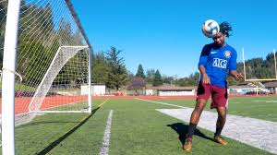
OVERHEAD PASS IMAGE

